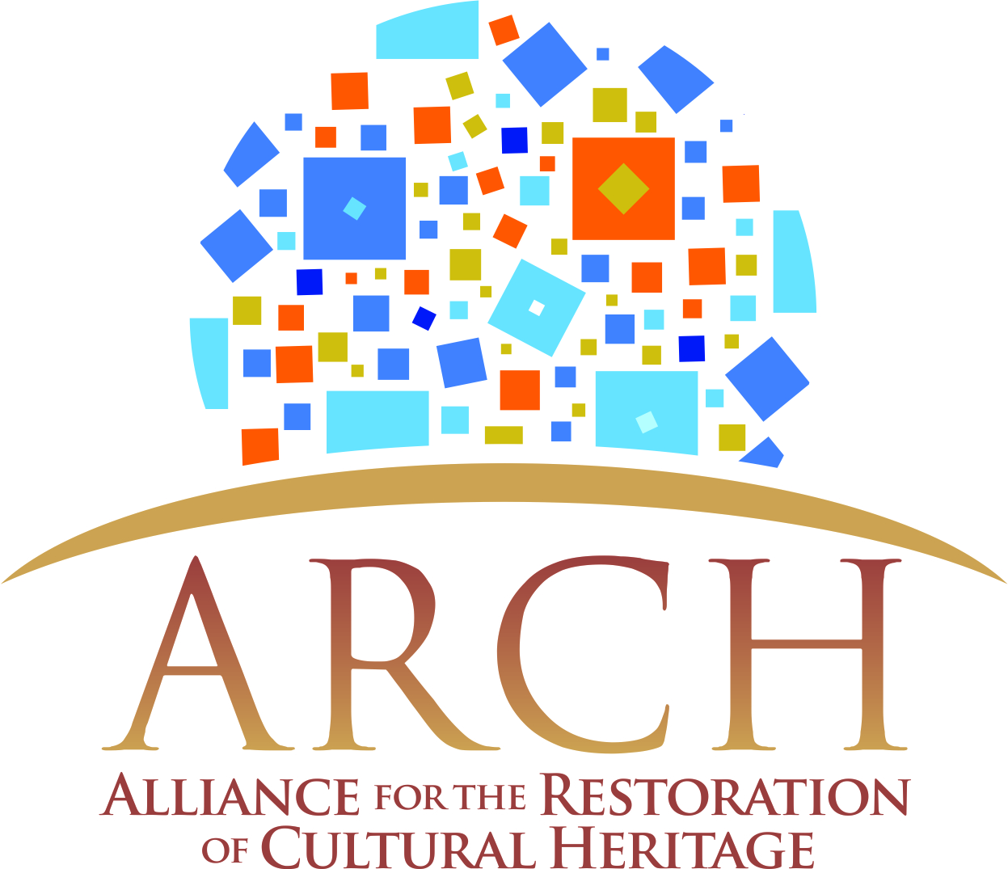

WHITE PAPER: MES AYNAK
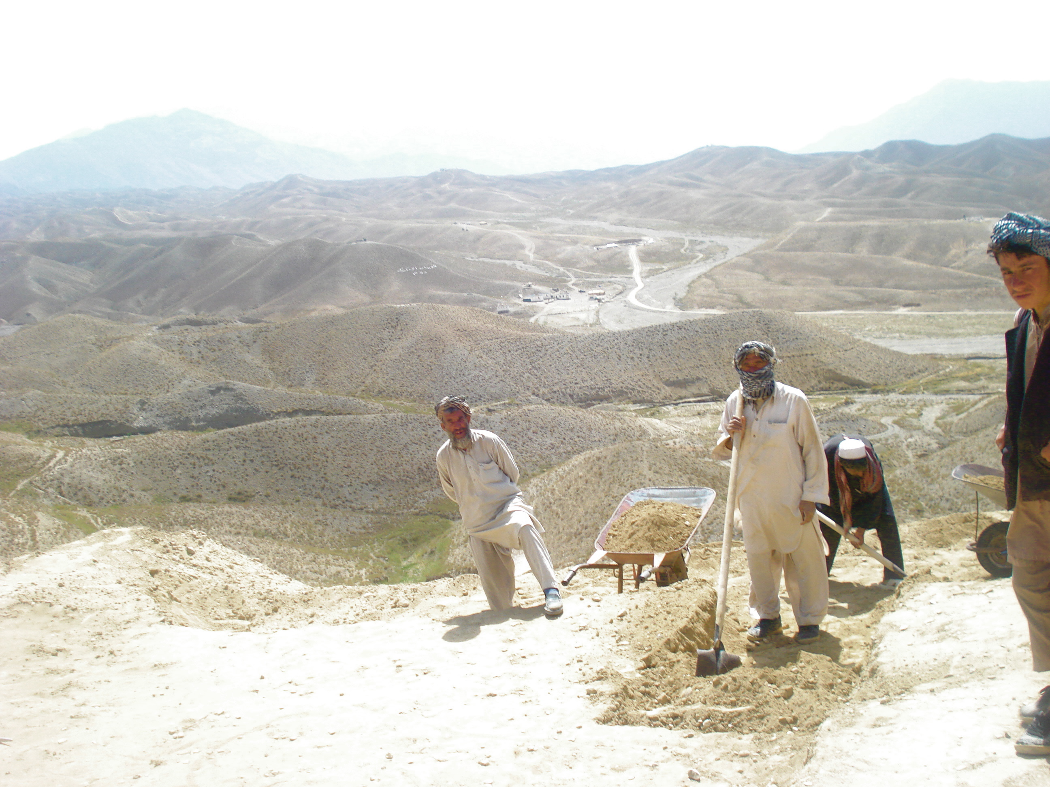
photo: Hamid Naweed
report prepared by Dr. Cheryl Benard
ARCH International, 2121 K. Street NW Suite 620, Washington DC 20037 March 2012
Executive Summary:
This White Paper addresses a situation of urgency, the heritage site Mes Aynak in Logar Province, Afghanistan. The paper and its recommendations are based on research conducted by ARCH International, in consultation with international subject matter experts, throughout 2011.
Mes Aynak is an archaeological site of considerable value. Beneath its approximately 400,000 square meters are the remains not only of several Buddhist monasteries, but also of a fortress, urban dwellings and earlier remnants of human habitation going back 5000 years or more. Its multiple layers of habitation contain information about the technological, economic, religious and social history of Afghanistan and more broadly, of this key transit region between Asia and Europe. Mes Aynak was centrally located on the Silk Road.
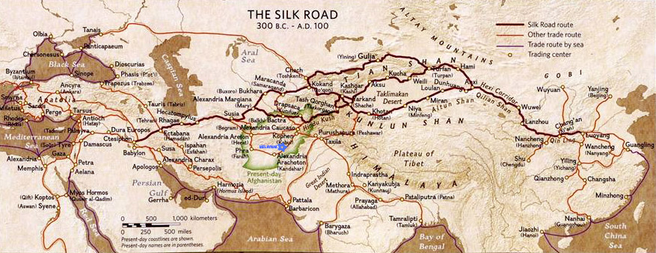
Mes Aynak also holds a very significant copper deposit. This is not a coincidence – the area originally attracted human settlement because of its copper, and over time became prosperous for the same reason, inviting the construction of dwellings, a garrison, lavishly decorated monasteries and more. Recently, the contract to mine this copper was obtained by the Chinese company MCC.
Currently, MCC plans to harvest at least a portion of the copper through surface mining, a method that entails the use of explosives and typically leaves behind a deep crater that over time fills with toxic sludge. Contamination of the ground water is an associated hazard. Fears about the release of arsenic and sulfuric acid into the environment, with resultant danger to public health, have also been expressed by experts.
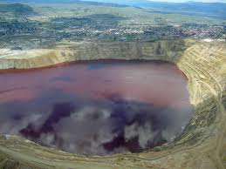
Berkeley Pit, Montana, is a toxic lake decades after the open pit mining ended

On the other hand, Afghanistan urgently needs the income from its natural resources, and it is hoped that the work opportunities associated with international mining projects will provide jobs, improve infrastructure and attract collateral investments. This poses a dilemma. The profits from mining are measurable and the expectation is that they will be received immediately. But historic patrimony and an intact environment are also critically important to the future prosperity and stability of Afghanistan.
In the case of Mes Aynak, two additional aspects need to be considered. The role of Afghanistan as a site of early technological innovation, and a wellspring of artistic and architectural achievements, promises to be a significant image change and a source of national pride and identity. Secondly, the possibility of preserving a valuable destination so close to Kabul holds the promise of touristic and educational travel and income for many years to come. To destroy this is a tangible and material loss.
In this paper, we identify a proposed way forward that maximizes the outcome on all fronts. It is our conclusion that creative application of modern mining technology, building on a constructive partnership between archaeologists and mining engineers and premised on a full and responsible analysis of the geological, geographical, economic and archaeological circumstances of each site in question, can make all of the above important goals possible: mining, jobs, and the preservation of portions of this historic site for future generations.
Indeed, this paper argues that if approached constructively, a partnership of cultural conservation, economic interests, and national development is possible and in Mes Aynak can become a model for the many projected future situations in Afghanistan and elsewhere, where archaeological remains and mineral deposits share the same physical location.

INTRODUCTION
Mes Aynak is located approximately twenty-five miles southeast of Kabul, in Logar Province. In 2007/2008, the Chinese mining company MCC (Metallurgical Corporation of China) won the contract to mine copper from this very rich deposit. However, the site also holds archaeological remains. Experts say these are significant, dating back 5000 years and spanning history from the Bronze Age through the Buddhist era and up to the early Islamic period.
The presence of important and large archaeological remains at this location has been well known since at least the 1960’s and preliminary excavations were conducted over the years by French, Russian and Afghan archaeologists. Nonetheless, the mining contract initially made no mention of archaeological finds. Indeed, some of the initial reporting stated that while conducting the initial mining exploration, engineers surprisingly happened upon these ruins. This is incorrect. Portions of the ruins were clearly visible at all times; their presence was known to inhabitants who in fact had been engaging in extensive looting over the years; the international archaeological community knew of this site and many famous archaeologists had worked there and published on the subject.
When their existence was finally taken note of in the context of the mining effort, a plan was developed to utilize the run-up to mining operations – i.e. the time period during which exploratory digging takes place, facilities are built, infrastructure is established etc. – to save some of the artifacts by removing them.
This approach is known as “salvage archaeology”, “rescue archaeology” or “mitigation.” In archaeology, this method is only chosen when there is no alternative, for example because an archaeological deposit is found in the middle of a heavily populated urban area during the construction of a subway station. Even then, city planners sometimes choose to build around them in order to preserve an original ancient portion of the site.

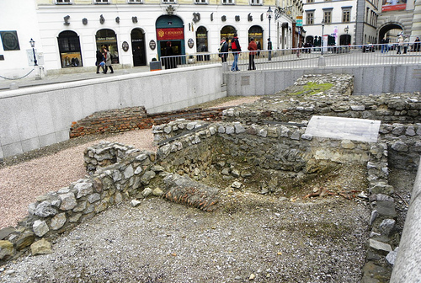
A section of Vienna’s posh First District has been permanently sectioned off to display Roman ruins and a mural found during subway construction.
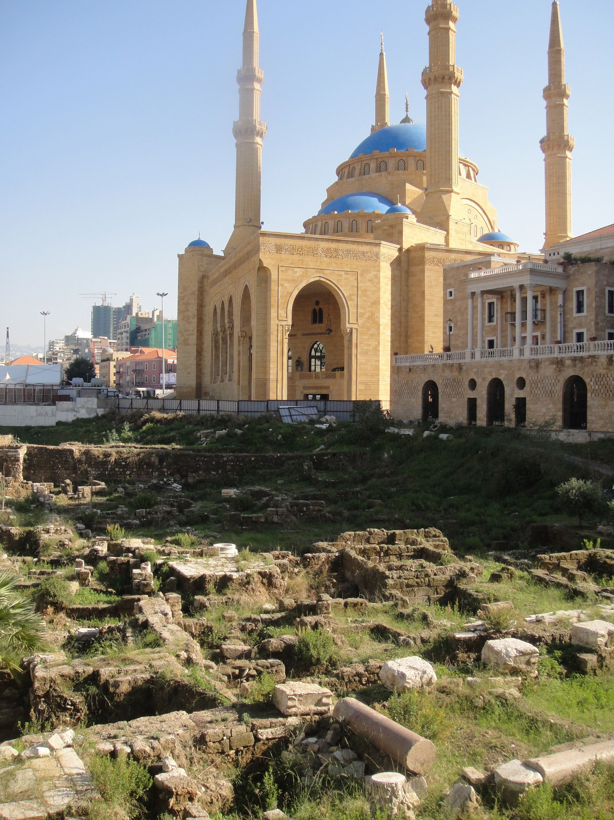
Many ancient cities wrestle with ways to reconcile their different epochs. Here, Roman ruins surround a mosque and church in Beirut, Lebanon.

It consists of limited documentation of the currently visible portions of the site and the removal of whatever artifacts can be taken away for conservation or placement in a museum – Kabul Museum - or a yet-to-be-built storage facility. The site itself, along with the still undiscovered and unexplored bulk of the historic remains - the buildings and structures themselves, the deeper layers of earlier habitation, the artifacts too large or too fragile to be moved, and most of those made in the locally typical manner from unbaked clay - is still slated for destruction.
Experts term this “one of the most intriguing ancient mining sites in Central Asia, if not the world;” they point out that the finds include “monumental statues of the Buddha that will have to be left in situ”(i.e. that cannot be moved); and that excavations would “almost certainly document” continuous habitation and economic activity over a period of many centuries, indeed millennia.

THE MINING CONTRACT:
Mes Aynak, in Afghanistan’s Logar province, holds a very significant deposit of copper – an estimated six million tons. In 2007/2008, the Chinese company MCC won the mining contract for this site from the Afghan government. This was preceded by an elaborate bidding process overseen by international reviewers; nonetheless, allegations have persisted that corruption was involved and that the since-replaced minister may have received as much as 30 million dollars.
At optimal extraction, 200,000 tons of copper are anticipated per year, which would generate an income of 450 million dollars for Afghanistan. There also are associated hopes for jobs, a railway, and a power plant.
Some independent observers and NGOs have questioned these expectations. Integrity Watch Afghanistan is concerned that the contract lacks binding timelines, and sees indications that despite contrary promises, MCC intends to largely employ Chinese workers. Doubts have also been expressed about the railway. Afghan authorities continue to hope for one, but there appears to be some uncertainty as to whether MCC has entered into a contractual obligation to build it or has only undertaken to explore its feasibility.
As always with a mining project of this magnitude and nature, environmental concerns are also an issue. Copper mining carries risks to groundwater and to the long-term topography of the site. Some question whether Afghan authorities, given the overall uncertainties of their governance and the persistent instability in the country and in Logar in particular, are in a position to put adequate environmental safeguards in place and maintain oversight. The likelihood of self-regulation by the Chinese company is also in some doubt. To help with these issues, the World Bank has given the Afghan government a grant of over 50 million dollars to expand its capabilities for oversight and management of the project.

SIGNIFICANCE OF THE SITE
In the judgment of subject matter experts, Mes Aynak is a location with the potential to be declared a World Heritage Site. A request to this effect has already initiated by the renowned Afghan archaeologist Zemaryalai Tarzi, although his action is symbolic, because such requests must come from a national government. To garner attention, he has launched a signature campaign with over 10,000 signatories to date.
Mes Aynak is important not just for one, but for three reasons: 1) it is a Bronze Age site; 2) it was a religious/population center during Afghanistan’s Buddhist era and contains several monasteries, the associated civilian dwellings and multiple structures and art works; and 3) it is believed to have been continuously inhabited from at least 3000 BC to the Early Islamic era.
The recent discovery of gold and gem jewelry items underscores the likelihood that this was a prominent settled area in the past, not just a residence for some monks and miners.

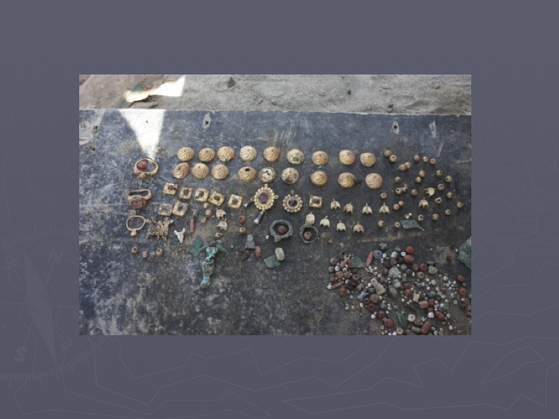
jewelry items recently found on site
While the Buddhist aspect is important, what makes the site special is this continuity of habitation across millennia. In Central Asia, the Bronze Age is dated at 2300-1700 BC. During this epoch, many foundations of human civilization were developed: the ability to smelt and work ores such as copper, the invention of writing, agriculture, and early systems of law and social stratification. Over 5000 years old, this is a site where early technology and society unfolded.
A site of this caliber merits thorough mapping and exploration. This is a prerequisite for an informed decision on how, where, and when to conduct the mining operation. To date, such a survey has not been carried out. Initially, there was not even any mention or consideration of the archaeological aspects of the site; that recognition came as an afterthought subsequent to the granting of the contract, even though the existence of massive archaeological remains at this location was well known. Until today, the site has not been properly surveyed or mapped and there appears to be no intention to do so. Small-scale surveys have taken place but in the view of subject matter experts, these were not comprehensive or adequately resourced and did not make use of available technological resources.
The scientific, historic and touristic value of Mes Aynak, as well as its potential qualification as a World Heritage site and segment of a World Heritage route (the Silk Road), have not been assessed. Options for mining in a way that preserves the site or at least its most valuable portions, have not been discussed or developed. Consequently, the relative costs and benefits have also not been explored, i.e., on the basis of present levels of information it is not possible to weigh the pros and cons of different mining outcomes against the possible advantages and disadvantages of leaving portions of the site intact for scientific and touristic use.
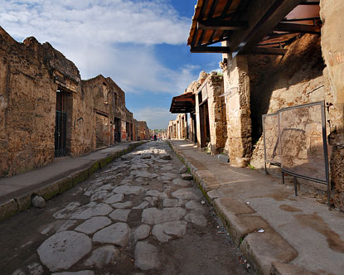
In Pompeii, Italy, visitors can tour the ruins of the ancient city. Tourists bring in
20 million dollars each year just at this one site alone.

Instead, what is happening at present is “salvage archaeology.” Experts have been given funding to document and remove as many items as they can in the time allotted. This is better than nothing. But as the terms “salvage archaeology” and “rescue archaeology” indicate, this is a path of last resort, not a desirable or good outcome. This is especially true given the magnitude and importance of the site:
- Experts believe that layers of habitation, including towns and commercial complexes from varying periods of history are likely to lie beneath the surface of this site.
- Ancient statues, jewelry, coins and portions of murals all have value and deserve to be exhibited in a museum. But, as many UNESCO conventions and experts attest, cultural heritage preservation is not a matter of just collecting and displaying individual statues and artifacts. It is their context that gives them meaning. The forum in Rome, or the city of Pompeii, convey the texture and the details of life and culture in a different era. The value would not be the same if one just removed the statues and some pottery shards from those two sites and put them in a museum. In sites that have historic continuity and where the remains are especially noteworthy, intact and extensive, the real value lies in keeping them in their historical placement.

It is fair to say that the stakeholders, for whatever reasons, have downplayed the archaeological and heritage aspects of this site. For example, the World Bank document “Mineral Resource Tenders and Mining Infrastructure Projects Guiding Principles, Case Study: The Aynak Copper Deposit, Afghanistan,” notes on page 51 that “the Aynak project area includes one of the most prominent new archeological sites in South Asia, Mes Aynak.” Yet the table of contents which is three pages long does not contain an entry for Mes Aynak or archaeology; instead, the sentences about this acknowledged major site are subsumed under “Regulatory, Cultural and Social Issues at Aynak” and the text itself gives the impression that the matter has been successfully resolved and there are no outstanding concerns or issues.
Mismanagement of Mes Aynak can have negative consequences for all parties involved. The procedures and the outcome will be judged by the international expert community in the decades to come, with potential fallout if it appears that due diligence was not applied for the protection of cultural heritage.
Afghanistan is a signatory to international conventions obligating it to protect such sites. Analogies to the Taliban’s destruction of the Bamiyan Buddhas are already been drawn in the press reporting. Commendably, China is spearheading an effort to have the Silk Road declared a World Heritage Route – pro-active steps to conserve portions of a Silk Road site such as Mes Aynak would contribute positively to this effort. This ancient site could potentially become a cutting edge model for mining that preserves antiquities.

RECOMMENDATIONS:

- First, an independent group of Afghan and international experts should conduct a proper assessment of the site, horizontally and vertically, to determine exactly what it holds and where its more important substrata are located. It should follow standard, state of the art procedures for a site of this importance and magnitude. This should culminate in the development of a master plan for the site.
- Until this is completed, no further action should be taken at the site. Bearing in mind that both the destruction of heritage objects, and their removal to a storage facility, are irreversible, neither should occur before the assessment is completed and a responsible plan has been formulated.
- Next, a technical and engineering committee should be convened to meet with the archaeologists and discuss and develop options for mining that allow for the preservation of the site or the most important portions of the site.
- Fourth, a joint group consisting of members of the above two committees should oversee the mining project during all phases and be available for advice and consultation.
- The approach should be documented with a view to creating a model for future comparable cases. The intersection of economic, social development, technological and cultural preservation goals is not unique to this site.

CONCLUSION:
Ideally, Mes Aynak can become a model case with a win-win outcome, pioneering methods for the extraction of resources in a way that is ecologically, culturally and historically responsible while meeting the needs of social development and the global economy.

- ARCH International is a registered non-profit 501©3 organization with headquarters in Washington D.C. It is dedicated to the support and restoration of physical and intangible cultural heritage endangered by conflict, post-conflict and war. A list of the consulted experts is separately available. Professor Hamid Naweed of ARCH conducted a site visit to Mes Aynak and held a series of conversations with the responsible authorities in Kabul in September 2011 and February 2012. The views expressed in this report are those of ARCH International. For more information, contact Dr. Cheryl Benard at cbenard@archinternational.org.
Nicolas Engel, of the French archaeological association DAFA, dates the first exploration of Mes Aynak at 1963. “The Buddhist Monasteries and Settlement at the Mes Aynak Copper Mine, Logar Province,” in ICOMOS, Heritage at Risk 2008-2010, Berlin 2010. Later, work was conducted there by Tarzi and by the renowned Russian archaeologist Viktor Sarianidi, and others.
Zemeryalai Tarzi and David Stronach, The Copper Mine at Mess Aynak, New Channel Media, undated online publication. Professor Tarzi is an Afghan-French archaeologist who conducted three official explorations in Mes Aynak in the 1970s.
See for example Dan Rather’s report, April 12, 2011, http://www.prnewswire.com/news-releases/dan-rather-reports-looks-at-afghanistans-largest-foreign-investment-project---a-copper-mine-now-controlled-by-the-chinese-government-119612414.html. The rumors have been sufficiently persistent that the Ministry of Mines, now under a different minister, took the unusual step of posting a reference to this matter on its official website. “Note: In 2009, there were some media reports of possible corruption in the form of bribes being taken for the award of the Aynak contract, although until now, any types of evidence in this regard has not been found but the position of the Government and the new management of the Ministry of Mines is that in case of any evidence found in this argument the government will seriously deal with the issue accordingly to country’s laws and other anti-corruption regulations.” http://mom.gov.af/en/page/1392, as per August 3, 2011.
this according to cables from the U.S. embassy in Kabul and in Beijing, published by wikileaks. http://www.cablegatesearch.net/cable.php?id=09BEIJING2918 and http://www.cablegatesearch.net/cable.php?id=09KABUL3101
- “Gold, platinum, chrome and copper mining, pose a direct risk to groundwater pollution. The extraction of minerals requires blasting and, often, dewatering of mines. Mining wastes from underground activities pollute ground water. Pollutants are spread through the aquifers of the region. The de-watering of mines can transport these wastes to the surface and facilitate the spreading of the wastes.” http://www.nwpg.gov.za/Agriculture/NW_ENVIRONMENTAL_OUTLOOK/chapter.asp?CHAPTER=11&PAGE=2&TITLE=Part%202. In the case of surface mining, hazardous chemicals are used.
- conflicts and issues have arisen in Peru and Zambia, to name just two examples. These have involved large scale riots in protest of poor working conditions and low pay. http://chinadigitaltimes.net/china/copper.
- UNESCO can only make such a designation at the request of a national government. Professor Tarzi has launched an online signature campaign, presumably to attract attention as a public relations method.
- see for example Christoph Machat, Michael Petzet, John Ziesemer(eds.), “Heritage at Risk, ICOMOS World Report 2008-2010 on Monuments and Sites in Danger, ICOMOS, Berlin 2010.
http://www.scotsman.com/news/international/afghanistan_s_ancient_jewels_finally_see_the_light_of_day_1_1973845
- DAFA has published a two part mini-survey. Mes Ainak, Archaeological Assessment Report, Transitory Document, DAFA assessment 15/XI/2010
- see for example UNESCO documents “Recommendation concerning the Preservation of Cultural Property Endangered by Public or Private Works”(1968); “UNESCO Recommendation Concerning the Safeguarding and Contemporary Role of Historic Areas”(1976); and the World Heritage Convention (1972) which states that setting is an attribute of authenticity and needs protection through the establishment of buffer zones. See especially also the “Xi’An Declaration on the Conservation of the Setting of Heritage Structures, Sites and Areas,” adopted in Xi’An, China by the 15th General Assembly of ICOMOS, October 2005.
- World Bank, Extractive Industries for Development Series 22, September 2011.
- Writing in Science Magazine, Andrew Lawler notes that “A decade after the Taliban destroyed the famous Bamiyan Buddhas…archaeologists are warning that Afghan antiquities are again at risk. This time the threat comes from a venture blessed by the Western-backed Afghan government.” “Copper Mine Threatens Ancient Monastery in Afghanistan,” Science Magazine, vol. 329, 30 July 2010. See also Heidi Vogt, “Chinese Copper Mine in Afghanistan Threatens 2,600 year-old Buddhist Monastery,” The Huffington Post, 14 November 2010; “Afghan Buddhist Relics: Archaeologists Issue Warning,” BBC News South Asia, 15 November 2010; Ann Marlow, “Rescuing Afghanistan’s Buddhist Heritage,” Wall Street Journal/wsj.com, September 17, 2010; Alex Rodriguez, “Teams scramble to save Afghan artifacts before copper mining begins,” Los Angeles Times, July 13, 2011; Joshua Foust, “How Chinese Mining is Destroying Afghanistan’s Historic Ruins,” The Atlantic, July 2011.

